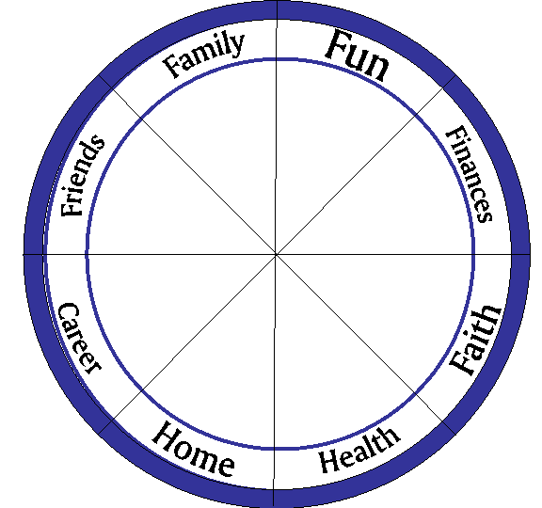
Annual GOAL PLANNING
Intentions, Desires, Dreams
Balance, Vision, Objectives
SMART Goals, Planning, Commitment,
Success, Accomplishment, Celebration!
#1 Evaluate & Design: Evaluate each area of your life. Consider adjustments that need to happen in the different areas of my life….

Current Status How I want it to be
Fun/Recreation
Finances (Money)
Me/Personal Growth
Health
Space (office/home)
Career Development
Friends/
Extended Family
Immediate Family

PICK ONE AREA TO FOCUS ON: __________________ (often 1 area if improved will improve other areas as well)
My Goal:
#2 – Planning: What do you have to do to reach your goal?

- My Big Picture Goal (make sure your goal is not too small. This is where you are headed, your big picture!)
- What I need to do to make that happen (Buckets or key focus for success)
- Roadblocks that could get in the way (RB) (What could stop you?)
- What to do? Ways I can overcome the roadblocks (action steps)
- So what? (if this happens, what will it mean to me?)
Goal Strategy Chart
Goal:
Focus #1:

Focus #2:

Road Block:

What To Do? /Action

Why? So What?

What To Do? /Action

Why? So what?

What To Do? /Action

Why? So What?
What To Do? /Action

Why? So What?
Road Block:
Road Block:

Road Block:

#3 Key Action Steps: Consider what key things you will need to do to accomplish your goal. Create a list of SMART milestones that are important to move you along the road to goal success.
#4 Setting Goal Themes and areas of focus: Considering your goal and the key action steps above; consider which areas you would like to focus on each month for the next year to keep you moving forward one step at a time. (i.e. accounting, processes, staffing, HR, marketing, etc.)

Jan.
Feb.
March
April
May
June
July
Aug.
Sept.
Oct.
Nov.
Dec.

#5 Monthly Planner for Goal Milestones: Considering your goal, outline each month they activities you will do in each month to keep you moving forward one step at a time.
- a milestone target – (i.e your goal is to double your sales by the end of the year, so each month, you will increase by 5%, so in 10 months you have doubled your goal.)
- special projects or initiatives you are doing to support accomplishing your goal (i.e. in Feb you might purge all files and update all contacts in support of organization)
- activities (1x or on-going) you are doing to overcome obstacles (i.e. 5 networking events/mo.)
Jan. | Feb. | March
  1
  2
  3
  4
  5
  1
  2
  3
  4
  5
  1
  2
  3
  4
  5
April | May | June
  1
  2
  3
  4
  5
  1
  2
  3
  4
  5
  1
  2
  3
  4
  5
July | Aug. | Sept.
  1
  2
  3
  4
  5
  1
  2
  3
  4
  5
  1
  2
  3
  4
  5
Oct. | Nov. | Dec.
  1
  2
  3
  4
  5
  1
  2
  3
  4
  5
  1
  2
  3
  4
  5
#6 STEP:

Consider this month…what two steps will I take to move forward with my goal?

1.

2.

Consider how to keep it in front of you:
- DOCUMENT YOUR VISION & GOAL
  - Find or make something that is a constant reminder of the vision you are moving towards. Put your vision/inspiration piece in a spot where you be motivated by it. (collage poster, photo, inspiration book, life map, etc.).
  - Write your goal and post in 3 spots to read daily.

- VISUALIZE & ANTICIPATE what it will take to make your goal happen?
- Visualize your goal at the end of the year – what does it look like when it is happening?
- Fill out the Goal Overview Chart; set objectives for each month.
- Set some milestones and put on the calendar to create a reminder accountability system.
- Share you vision and goals with your family and co-workers.

- Design Personal ACCOUNTABILITY
  - Share your goal with your leader, manager, team
  - Get a buddy
  - Work with a coach

GOAL/PLANNING SUMMARY SHEET
Wheel of Life Action Steps: Consider the other areas of your wheel that had some actions that would move you closer to your ten. They might not be your main area of focus, but are simple things you could do in the coming year to improve your life balance.

Big Picture GOAL Statement:

Goal Deliverables (measurable elements of my goal)
1
2
3
4
5

Goal Support Activities (structures or activities I will do to ensure I overcome any potential roadblocks)
 | Focus #1 |  | Focus #2
1 |  | 1
2 |  | 2
3 |  | 3
4 |  | 4
5 |  | 5
6 |  | 6
7 |  | 7
8 |  | 8
9 |  | 9
10 |  | 10

